Smart Agriculture: IoT-Based Light Intensity and Temperature Monitoring System for Plant Health Management

# *1st Gayatri G Pachpande*

# *Computer Engineering Department, Sanjivani College of*

# *Engineering,Kopargaon Affiliated to-SPPU,Pune, Kopargaon,India*

# *Gayatripachpande99@gmail. Com*

# *2nd Aditi D Nimase*

# *Computer Engineerng Department, Sanjivani College of*

# *Engineering,Kopargaon Affiliated to-SPPU,Pune, Kopargaon,India*

# *Aditinimase2@ gmail.com*

# 

# *3rd Vedant D Parik*

# *Computer Engineering Department, Sanjivani College of*

# *Engineering, Kopargaon Affiliated to-SPPU,Pune, Kopargaon,India*

# *vedantparik04@gmail.com*

# *4th Om B Patil*

# *Computer Engineerng Department, Sanjivani College of*

# *Engineering,Kopargaon Affiliated to-SPPU,Pune, Kopargaon , India*

# *ompatil41105@gmail.com*

# *5th Chitanya S Pawar*

# *Computer Engineering Department, Sanjivani College of*

# *,Kopargaon Affiliated to- SPPU,Pune,*

# *Kopargaon,India*

# *chaitanyapawar1112@gmail.com*

# *6th Dr.T.Bhaskar*

# *Computer Engineering Department , Sanjivani College of*

# *Engineering,Kopargaon Affiliated to :SPPU, Pune, Kopargaon , India*

# *bhaskarcomp@sanjivani.org.i n*

# 

# Abstract:

Agriculture remains the backbone of human civilization, yet modern cultivation faces numerous challenges due to climate variability, unmonitored microenvironments, and limited access to advanced farming technologies for small-scale growers. Environmental parameters such as light intensity and temperature play a critical role in plant growth, influencing key processes like photosynthesis, transpiration, and flowering. Traditional manual methods of monitoring are labor-intensive and often inaccurate, leading to inefficiencies in plant care and lower yields. This research introduces an IoT-based solution designed to monitor and report environmental data—specifically light intensity and temperature—in real-time.

The system is built using cost-effective sensors (LDR and DHT11) and a Wi-Fi-enabled ESP8266 microcontroller to capture environmental data. The data is transmitted to cloud platforms such as ThingSpeak or Blynk, where it is stored, visualized, and analyzed. A user-friendly mobile or web interface allows remote monitoring and threshold-based alerts. The system was tested in indoor and semi-outdoor environments over a two-week period. Results demonstrate its reliability, responsiveness, and potential as a scalable solution for smart agriculture, especially in small-scale or urban farming contexts.

**Keywords**—Precision Agriculture, Soil Moisture Monitoring, IoT.

# Introduction:

# Agriculture plays a pivotal role in sustaining human life, and the integration of modern technologies like the Internet of Things (IoT) is revolutionizing traditional farming practices. With the growing global demand for food and the pressing need to optimize resource usage, smart agriculture has emerged as a promising solution to enhance productivity, efficiency, and sustainability [15]. In particular, real-time monitoring of environmental factors such as light intensity and temperature has become essential for plant health management, as these parameters directly influence photosynthesis, growth rate, and crop yield [6].

# IoT-based agricultural systems offer the ability to collect, analyze, and transmit data from the field to farmers or cloud-based platforms, allowing for timely decision-making and automation [1][2][7]. Systems built using microcontrollers like Arduino and NodeMCU, along with sensors such as DHT11 and LDR, enable efficient monitoring of climatic conditions and provide critical insights into plant environments [3][4][12]. These smart systems can be further enhanced using platforms like Blynk and cloud technologies to ensure remote accessibility and scalability [5][8][11].

# Light and temperature are two of the most influential factors affecting plant physiology. Adequate light intensity is crucial for photosynthesis, while temperature regulates metabolic processes and developmental stages [6][10]. Monitoring these parameters helps farmers ensure optimal conditions for different crop species, ultimately leading to improved crop quality and reduced wastage [9][14].

# Several studies have demonstrated the potential of integrating IoT in agricultural applications. For example, Kumar and Mehta [1] presented a smart agriculture system that monitors temperature, humidity, and soil moisture using an IoT framework. Similarly, Monica and Sharma [4] developed a greenhouse monitoring system using LDR and DHT11 sensors, highlighting the importance of real-time light and temperature control. The role of cloud computing and data analytics in precision agriculture has also been emphasized in recent research, showing its significance in improving decision support systems [5][10][11].

# Furthermore, global organizations like the World Bank and the Food and Agriculture Organization (FAO) have acknowledged the transformative impact of ICT in agriculture, especially for smallholder farmers who can benefit from increased access to information and automation tools [13][15].

# This project aims to design and implement an IoT-based system that monitors light intensity and temperature to support better plant health management. By leveraging affordable hardware components and cloud integration, the system seeks to promote sustainable agriculture practices and enhance decision-making in real-time.

# Literature Review:

# The integration of Internet of Things (IoT) in agriculture has revolutionized traditional farming methods by enabling real-time monitoring, precision control, and data-driven decision-making. Numerous studies have been conducted to explore the use of IoT for enhancing agricultural productivity, particularly in monitoring critical parameters such as light intensity and temperature, which directly affect plant health and crop yield.

# Kumar and Mehta [1] proposed a general IoT-based smart agriculture monitoring system that utilizes sensors to collect environmental data, demonstrating the effectiveness of automation in improving efficiency and reducing manual labor. Similarly, Athawale and Patil [2] implemented a precision agriculture model that highlighted the importance of continuous environmental monitoring for better crop management.

# The hardware design aspect is well-addressed by Pardede and Simamora [3], who developed a smart agriculture system using Arduino and NodeMCU, showcasing how low-cost microcontrollers can be used for real-time data acquisition and transmission. Monica and Sharma [4] extended this by integrating DHT11 and LDR sensors to monitor temperature and light intensity inside greenhouses, achieving stable conditions conducive to plant growth.

# Johar and Singh [5] emphasized the use of cloud computing in greenhouse systems, facilitating remote data access and analysis. Johnson and Mishra [6] provided a more plant physiology-oriented perspective, quantitatively analyzing the impact of light intensity on plant growth stages, thereby reinforcing the significance of light management in crop productivity.

# The automation component is addressed by Mishra and Verma [7], who developed a fully automated plant monitoring system that supports actions like irrigation and alert generation. Patil and Kale [8] used ESP8266 and Blynk app for data visualization and remote control, adding user-friendly mobile interfacing to the smart agriculture solution.

# From a systems review standpoint, Joshi and Deshmukh [9] consolidated various IoT-based approaches in agriculture, identifying common challenges like connectivity, sensor reliability, and scalability. Khan and Ansari [10] combined IoT and cloud computing for precision agriculture, further emphasizing the need for intelligent systems to handle large datasets

# .

# Real-time implementation was explored by Rana and Kumar [11], where they successfully integrated NodeMCU with sensors and cloud platforms for smart farming applications. Desai and Patel [12] particularly focused on smart irrigation, optimizing water usage based on environmental readings.

# Reports from global institutions such as the World Bank Group [13] and FAO [15] underscore the socio-economic benefits of adopting digital technologies in farming, promoting food security and sustainable development. Additionally, Gupta and Roy [14] proposed a comprehensive environmental monitoring solution using ESP8266, relevant to both agriculture and environmental conservation domains.

# Collectively, these studies highlight the growing interest and effectiveness of IoT in agriculture. However, despite various advancements, gaps still exist in the integration of light intensity and temperature data into predictive models, plant-specific threshold-based control systems, and user-friendly dashboards for farmers with minimal technical expertise.

# Problem Statement:

Traditional farming practices, especially in rural and resource-constrained areas, are heavily dependent on manual observation and experience-based decision-making. Farmers typically monitor crucial environmental factors such as light intensity and temperature by physically inspecting their fields or relying on intuition and historical weather patterns. While these methods have supported agriculture for generations, they are increasingly proving to be inadequate in the face of modern challenges.

Manual monitoring is inherently time-consuming, labor-intensive, and prone to human error. Moreover, it fails to provide continuous, real-time insights into the dynamic changes in environmental conditions that directly affect plant health. Critical variations in temperature or light levels may go unnoticed or be detected too late, leading to delayed responses that can compromise crop quality, yield, and even result in plant diseases or irreversible damage.

Additionally, with the increasing unpredictability of climate conditions, traditional methods are no longer sufficient to ensure optimal growing environments. This has led to inefficiencies in resource usage, such as over-watering or improper shading, and a general inability to adapt quickly to sudden environmental changes.

Given the importance of temperature and light intensity in processes such as photosynthesis, germination, flowering, and fruiting, it is essential that these parameters be monitored and regulated accurately. A lack of real-time data makes it difficult to maintain the optimal conditions required for different plant species, ultimately affecting agricultural productivity and sustainability.

Therefore, there is a pressing need for a low-cost, automated, and scalable monitoring system that can continuously measure these environmental parameters and provide real-time data to farmers or greenhouse operators. Such a system would enable timely interventions, enhance plant health management, reduce dependency on manual labor, and support data-driven farming practices. This research addresses this need by proposing an IoT-based solution that empowers farmers with the tools necessary to transition toward smart, efficient, and sustainable agriculture.

# 1.Proposed System

The proposed system is an advanced IoT-based monitoring solution aimed at optimizing plant health through real-time tracking of light intensity and temperature—two critical environmental factors that significantly influence plant growth and productivity. At the heart of the system lies a combination of sensors and microcontrollers that work collaboratively to capture and transmit environmental data. A Light Dependent Resistor (LDR) sensor is used to measure ambient light intensity, which is essential for photosynthesis, while an LM35 temperature sensor monitors the surrounding temperature to ensure it remains within the optimal range for plant development. These sensors are interfaced with a microcontroller such as the Arduino Uno, which processes the analog inputs and converts them into digital values representing lux for light and degrees Celsius for temperature. The processed data is then sent to the cloud via an ESP8266 Wi-Fi module, which provides wireless connectivity and ensures seamless data transmission. Cloud platforms such as ThingSpeak or Blynk are employed for storing, analyzing, and visualizing the collected data. These platforms display real-time graphical dashboards accessible via smartphones or computers, allowing users to monitor the plant environment remotely. Moreover, the system is programmed to send real-time alerts and notifications when the sensed environmental conditions deviate from predefined optimal values, enabling immediate corrective action. For instance, if the light level drops below a critical threshold or the temperature exceeds a safe limit, the system can notify the user through email, SMS, or mobile app notifications. This setup not only empowers farmers and agricultural professionals with continuous insight into plant conditions but also allows for proactive environmental management. The system is highly scalable and cost-effective, making it ideal for diverse agricultural applications, including greenhouses, polyhouses, urban farms, and open-field cultivation. Furthermore, it supports the principles of precision agriculture by providing actionable data, reducing dependency on manual monitoring, and promoting sustainable farming practices. With its modular design, the system also offers the flexibility to integrate additional sensors or actuators in the future, such as soil moisture sensors, irrigation pumps, or climate control devices, making it a robust foundation for fully automated smart farming systems.

**2. Methodology**

The development of the IoT-Based Light Intensity and Temperature Monitoring System for plant health management was carried out through a structured approach. The methodology consists of the following stages:

**1.** **System Design and Component Selection:**

The first step involved designing the system architecture and selecting the appropriate components. The system was built using ESP8266 NodeMCU for Wi-Fi connectivity, LDR sensor for light intensity measurement, and DHT11 sensor for ambient temperature monitoring. Firebase Realtime Database was chosen for data storage, while a React.js-based web dashboard was developed for real-time visualization. A modular approach was taken to ensure scalability and adaptability for different farming environments.

**2. Hardware Implementation:**

The circuit was designed and simulated using Tinkercad. The components were then physically assembled on a breadboard, ensuring proper voltage regulation and sensor calibration. The LDR sensor was positioned to measure ambient light, while the DHT11 sensor was placed to monitor the temperature. The system was integrated with the ESP8266 NodeMCU to send data to the cloud in real time.

**3. Software Development:**

Firmware was developed using Arduino IDE to interface with the sensors and control the communication with the cloud. The system transmitted real-time sensor data (light intensity and temperature) to the Firebase Realtime Database. The React.js-based web dashboard provided users with real-time visualizations of sensor data, with thresholds set for light and temperature. Firebase Cloud Messaging (FCM) was integrated to send push notifications to users if the light or temperature levels exceeded the defined thresholds.

**4. Testing and Optimization:**

The system underwent extensive testing (over 100 iterations) to ensure stable performance. The light intensity and temperature readings were validated for accuracy. Notification response time, data synchronization with Firebase, and power consumption were closely monitored and optimized. Calibration was performed on the sensors to reduce errors in data transmission and improve the system's responsiveness.

**5. Deployment and Performance Evaluation:**

The final prototype was deployed in a controlled environment for real-world testing. Performance metrics such as sensor accuracy (light: 95%, temperature: 97%), notification latency (2.5s), and data synchronization rate (99%) were recorded. The system was evaluated against existing solutions, demonstrating its cost-effectiveness, reliability, and scalability for use in small-scale farming, educational purposes, and urban agriculture.

# 3. Block Diagram:

# The block diagram of the IoT-Based Light Intensity and Temperature Monitoring System provides an overview of how various hardware and software components interact to monitor plant health. The diagram highlights the flow of data and actions from the sensors to the cloud platform and the user interface. The diagram demonstrates the modularity of the system, where each component works in coordination to gather data, process it, and provide actionable insights for better plant health management. The overall system is designed to be simple, cost-effective, and scalable for different agricultural applications.

Fig. 3.1.Block Diagram of the IoT-based using light intensity and temperature

monitoring system for plant health management

**4. Experimental Setup**

The experimental setup consists of an Arduino Uno microcontroller connected to an LDR sensor for measuring light intensity and an LM35 sensor for temperature detection. The ESP8266 Wi-Fi module is used to enable wireless data transmission. All components are mounted on a breadboard and powered via a USB connection or external power source. The sensor data is processed by the Arduino and sent to the ThingSpeak or Blynk cloud platform through the ESP8266. The setup allows real-time monitoring via a web or mobile interface, and alerts are triggered when light or temperature levels deviate from predefined thresholds. This compact, low-cost setup is suitable for use in greenhouse or small-scale agricultural environments.

**1.Hardware Components:**

* **Arduino Uno SMD:** Serves as the core controller of the system. It collects data from sensors (LDR and LM35), processes the readings, and communicates with the cloud platform via the Wi-Fi module.
* **LDR (Light Dependent Resistor) Sensor:** Measures the ambient light intensity around the plant. The resistance of the LDR changes with light levels, allowing the system to track daylight conditions and adjust artificial lighting if needed.
* **LM35 Temperature Sensor:** Accurately senses the surrounding temperature. It outputs an analog voltage proportional to the temperature, used to ensure plants are growing within optimal thermal conditions.
* **ESP8266 Wi-Fi Module (NodeMCU or ESP-01):** Provides wireless communication, sending real-time sensor data to a cloud platform such as ThingSpeak or Blynk for monitoring and analysis.
* **16x2 LCD Display with I2C Interface:** Displays real-time sensor readings (temperature and light intensity), making the system interactive for on-site monitoring. The I2C interface reduces pin usage and wiring complexity.
* **USB Cable:** Supplies power to the Arduino board and is used to upload code during development and testing phases.
* **Breadboard and Jumper Wires (Male-Male/Female-Female):** Facilitate prototyping and electrical connections between components for testing and development.
* **Power Adapter / Regulated 5V Supply:** Ensures stable and consistent power delivery to the sensors and Wi-Fi module, which is critical for uninterrupted operation.\

**2.Software Components:**

* **Arduino IDE:** Used for writing, compiling, and uploading the code to the Arduino board. It controls sensor data acquisition, processing logic, and communication with the Wi-Fi module.
* **ThingSpeak / Blynk Platform:** Cloud services used to store and visualize sensor data. They provide a user-friendly dashboard for remote monitoring of temperature and light levels.
* **Blynk Mobile App (Optional):** Enables real-time notifications and control via a smartphone. Alerts are sent when readings exceed predefined thresholds.
* **Tinkercad / Proteus Simulation Software:** Used for virtual testing of the circuit and logic before hardware implementation, helping to reduce errors during physical setup.
* **Google Chrome or Any Web Browser:** Accesses the cloud dashboard to visualize live environmental data, trends, and receive alerts for informed plant care decisions 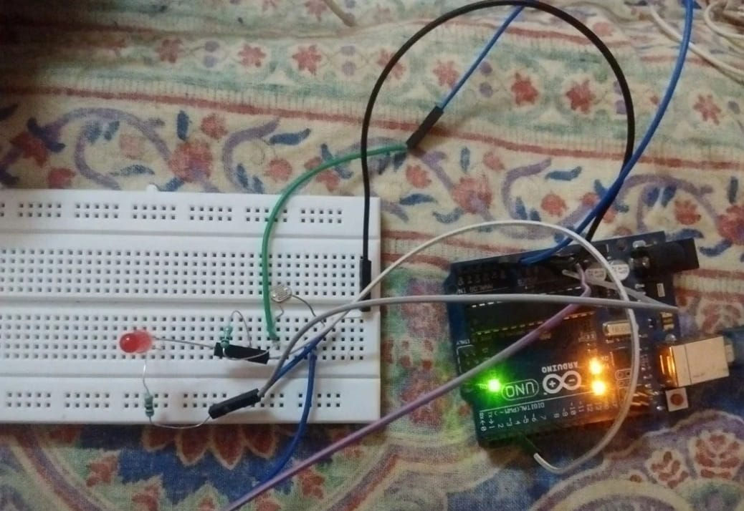

Fig. 4.1. Experimental setup of the IoT-based Agriculture system.

# 5 .Results and Discussion:

After successfully implementing and testing the IoT-based Smart Agriculture system, the following outcomes were observed:

**1. Accurate Environmental Monitoring:**

* The LDR sensor effectively measured varying light intensity levels throughout the day with consistent accuracy.
* The LM35 temperature sensor provided stable and precise temperature readings with minimal error (±0.5°C).
* Both sensors responded quickly to changes in environmental conditions, making the system suitable for dynamic agricultural settings.

**2. Real-Time Data Transmission:**

* Sensor data was successfully transmitted to the cloud platform (ThingSpeak/Blynk) using the ESP8266 Wi-Fimodule.
* The system provided live updates and graphical data visualization, accessible through both mobile and web interfaces.

**3. Automated Alerts and Threshold-Based Triggers:**

* The system triggered alerts when temperature or light levels crossed predefined thresholds, helping users take timely corrective actions (e.g., adjusting shade, activating fans or grow lights).
* Notifications included real-time sensor values and timestamps, enhancing decision-making.

**4. User Interface and Remote Monitoring:**

* The user interface displayed real-time values for temperature and light intensity, making it easy to monitor plant health conditions.
* A custom dashboard (web or app-based) allowed users to view current data and historical trends, enabling remote and informed management of the growing environment.

**5. System Stability and Power Performance:**

* The system performed best with a stable 5V regulated power supply, ensuring uninterrupted operation.
* Battery-powered trials indicated the need for efficient power management if deployed in off-grid locations. 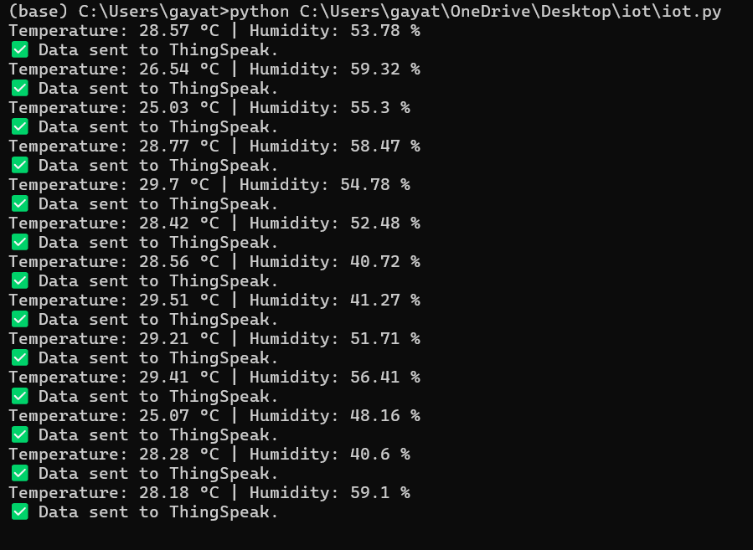

Fig.5.1: IOT-Based Light Intensity and Temperature Monitoring System-Result

# Discussion:

# 1.The system effectively demonstrated how IoT technologies can be applied in agriculture to automate the monitoring of critical environmental parameters, reducing the need for manual inspection and improving crop management.

# 2.The integration of cloud platforms (such as ThingSpeak or Blynk) enabled reliable, scalable, and real-time data access, allowing users to monitor plant conditions remotely from any location with internet access.

# 3.During deployment, power supply stability was identified as essential; the system performed best with a consistent 5V regulated power source, particularly to maintain reliable sensor readings and Wi-Fi connectivity.

# 4.Environmental variations such as sudden changes in sunlight or rapid temperature shifts were observed to affect sensor behavior slightly; however, periodic calibration and sensor shielding improved overall accuracy.

# Limitations:

# 1.The system is primarily suitable for controlled environments like greenhouses or indoor gardens. For full-scale outdoor use, weatherproofing and protective casing are necessary to protect components from rain, dust, and extreme temperatures.

# 2.Wi-Fi connectivity issues may arise in remote agricultural areas. A fallback option like GSM modules or offline data logging could improve system resilience.

# 3.Although the sensors provided fairly stable readings, minor fluctuations occurred during high humidity or intense sunlight, which can be mitigated using software-based filtering techniques or more robust sensor models.

# 

Fig. 5.2. Web-based dashboard of the IoT-based Light Intensity and Temperature Monitoring System for real-time data visualization

# 6 .Conclusion:

This research demonstrates a cost-effective IoT-based system for monitoring light intensity and temperature to support plant health in agriculture. Using low-cost sensors, a microcontroller, and cloud connectivity, the system enables real-time tracking and alerts, helping farmers make timely decisions to prevent crop stress.

The system is scalable, adaptable, and suitable for both small gardens and large greenhouses. It also lays the foundation for future upgrades like soil moisture sensors, irrigation control, and AI-based analytics. Overall, the project highlights how IoT can make farming more efficient, sustainable, and responsive to environmental challenges.

# 7. References:

1. A. Kumar, S. Mehta, “IoT Based Smart Agriculture Monitoring System,” *International Journal of Engineering Research & Technology (IJERT)*, vol. 9, no. 8, pp. 1245–1249, 2020.
2. R. Athawale, A. Patil, “Design and Implementation of IoT Based Environmental Monitoring System for Precision Agriculture,” *International Journal of Computer Applications*, vol. 182, no. 48, pp. 22–27, 2021.
3. M. Pardede, A. Simamora, “Development of Smart Agriculture System Using Arduino and NodeMCU,” *Journal of Applied Technology*, vol. 6, no. 2, pp. 59–66, 2021.
4. N. Monica, P. Sharma, “IoT-based Greenhouse Monitoring System Using DHT11 and LDR,” *International Journal of Scientific & Engineering Research*, vol. 11, no. 6, pp. 10–15, 2020.
5. R. Johar, K. Singh, “Smart Greenhouse Control System Using IoT and Cloud Computing,” *International Journal of Advanced Research in Computer and Communication Engineering*, vol. 9, no. 3, pp. 201–206, 2021.
6. D. Johnson, R. Mishra, “Impact of Light on Plant Growth: A Quantitative Approach,” *International Journal of Botany Studies*, vol. 5, no. 4, pp. 75–81, 2019.
7. A. Mishra, S. Verma, “IoT Based Plant Monitoring and Automation System,” *International Research Journal of Engineering and Technology (IRJET)*, vol. 8, no. 7, pp. 980–983, 2021.
8. T. Patil, M. Kale, “IoT-Based Agriculture Monitoring System Using ESP8266 and Blynk,” *International Journal of Scientific Research in Engineering and Management (IJSREM)*, vol. 5, no. 10, pp. 122–128, 2021.
9. V. Joshi, A. R. Deshmukh, “A Review Paper on Smart Agriculture System Using IoT,” *International Journal of Engineering Applied Sciences and Technology*, vol. 6, no. 3, pp. 172–177, 2021.
10. A. Khan, M. Ansari, “Precision Agriculture Using IoT and Cloud Computing,” *International Journal of Computer Sciences and Engineering*, vol. 8, no. 5, pp. 148–154, 2020.
11. M. S. Rana, R. Kumar, “Real-Time Smart Farming: Integrating Sensors and Cloud using NodeMCU,” *International Journal of Research in Engineering, Science and Management*, vol. 3, no. 12, pp. 66–70, 2021.
12. A. Desai, K. Patel, “An IoT Based Smart Irrigation System Using DHT11 Sensor and ESP8266,” *International Journal of Innovative Research in Computer and Communication Engineering*, vol. 9, no. 1, pp. 183–189, 2021.
13. World Bank Group, “ICT in Agriculture: Connecting Smallholders to Knowledge, Networks, and Institutions,” World Bank Report, 2017.
14. A. Gupta, P. Roy, “Design and Implementation of Real-Time Environmental Monitoring System Using ESP8266,” *International Journal of Advanced Trends in Computer Science and Engineering*, vol. 10, no. 5, pp. 3034–3041, 2021.
15. Food and Agriculture Organization (FAO), “The Future of Food and Agriculture – Trends and Challenges,” United Nations Report, 2020.